<https://www.ibm.com/support/pages/websphere-liberty-developers>

Download/unzip: WebSphere Liberty Web Profile 8 22.0.0.11

To create a default server

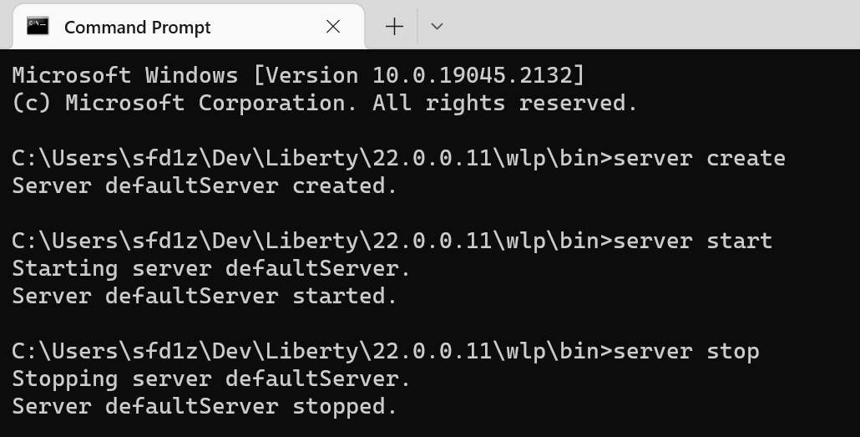

Copy your old entries in server.env from your previous Liberty server to this new server.env file.

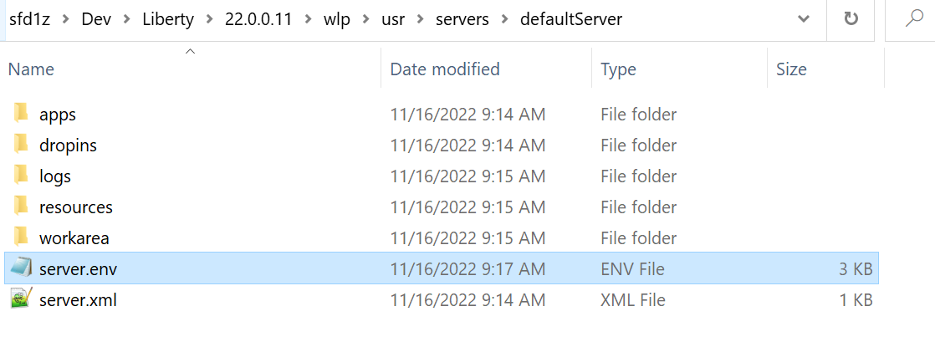

Setup a Liberty server runtime environment in eclipse

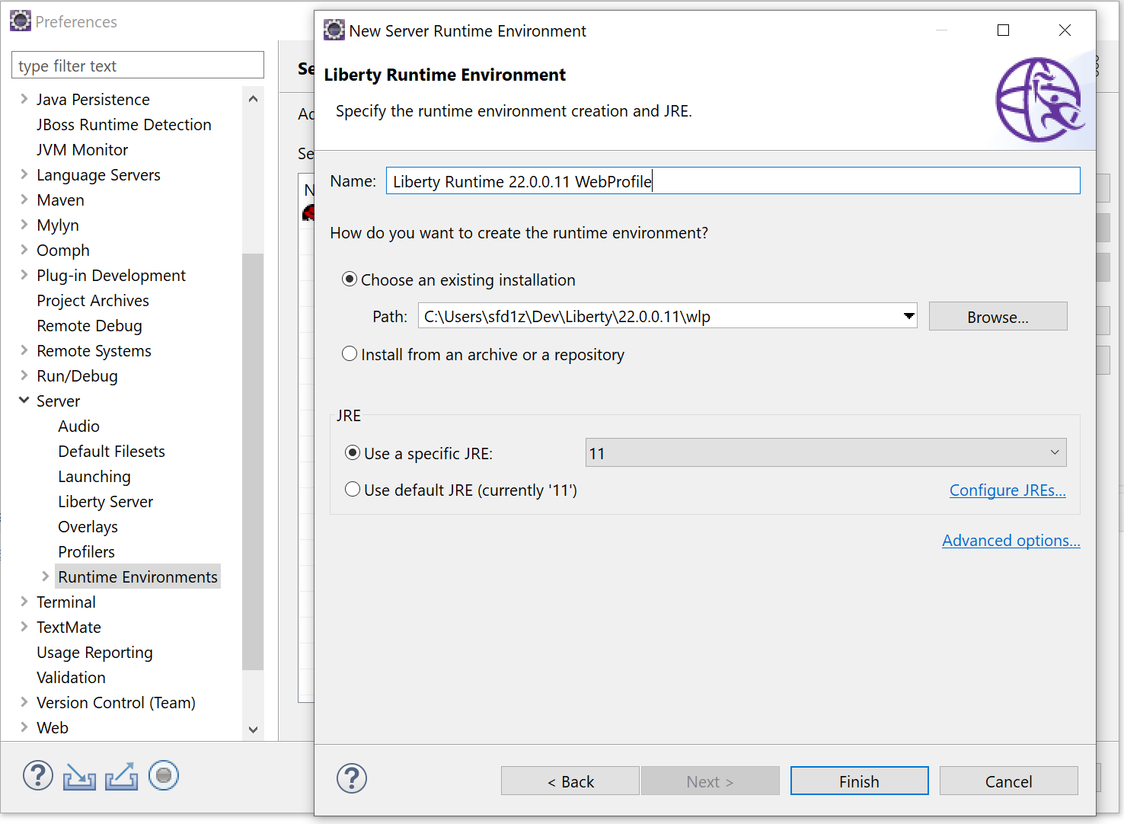

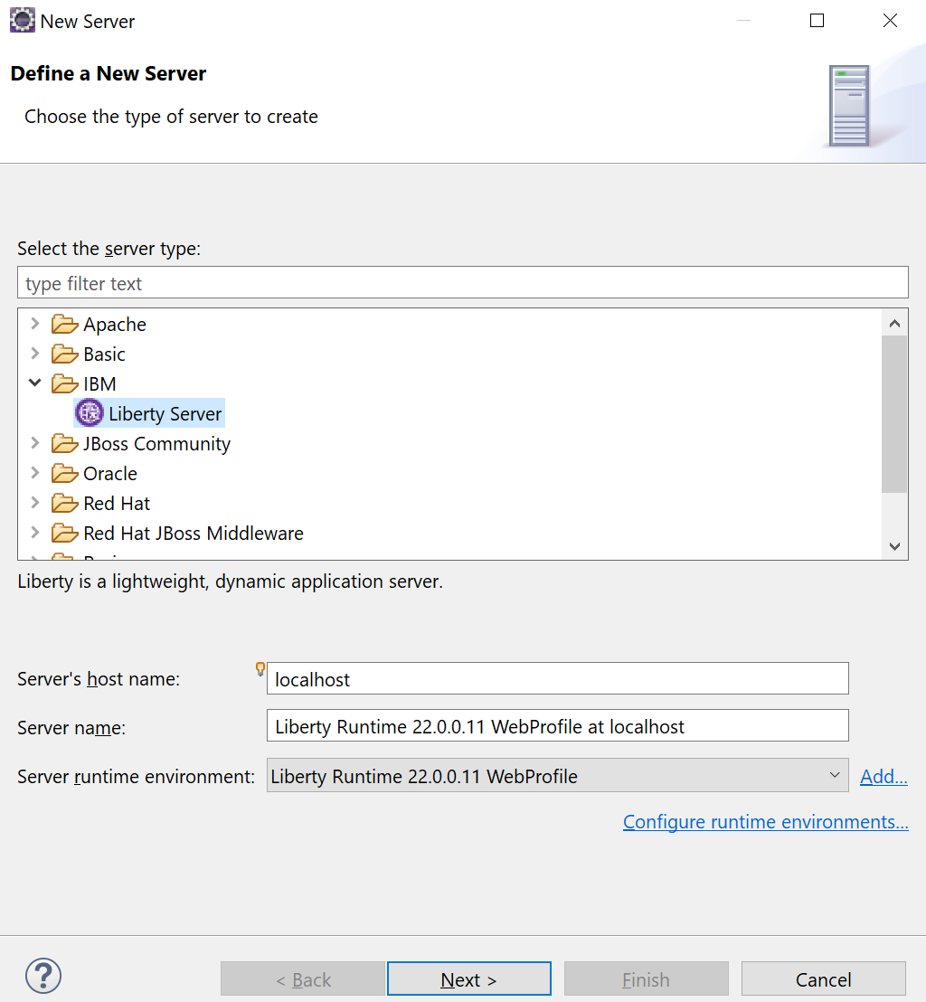

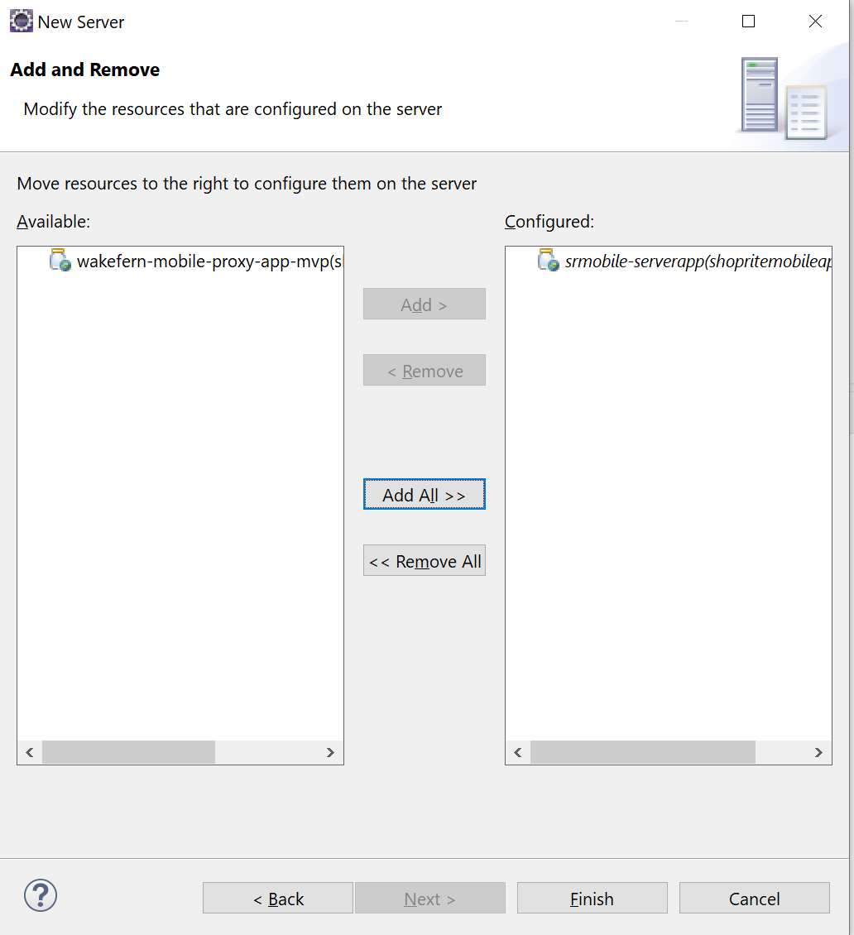

IMPORTANT: the first line in the server.env right after the defaultserver is created, it has a keystore_password. Don’t delete it or comment out until you run the server for the first time.

See the blue highlighted line, the server uses this password to create a default keystore.

After that, you can comment this keystore_password line out, see next screenshot

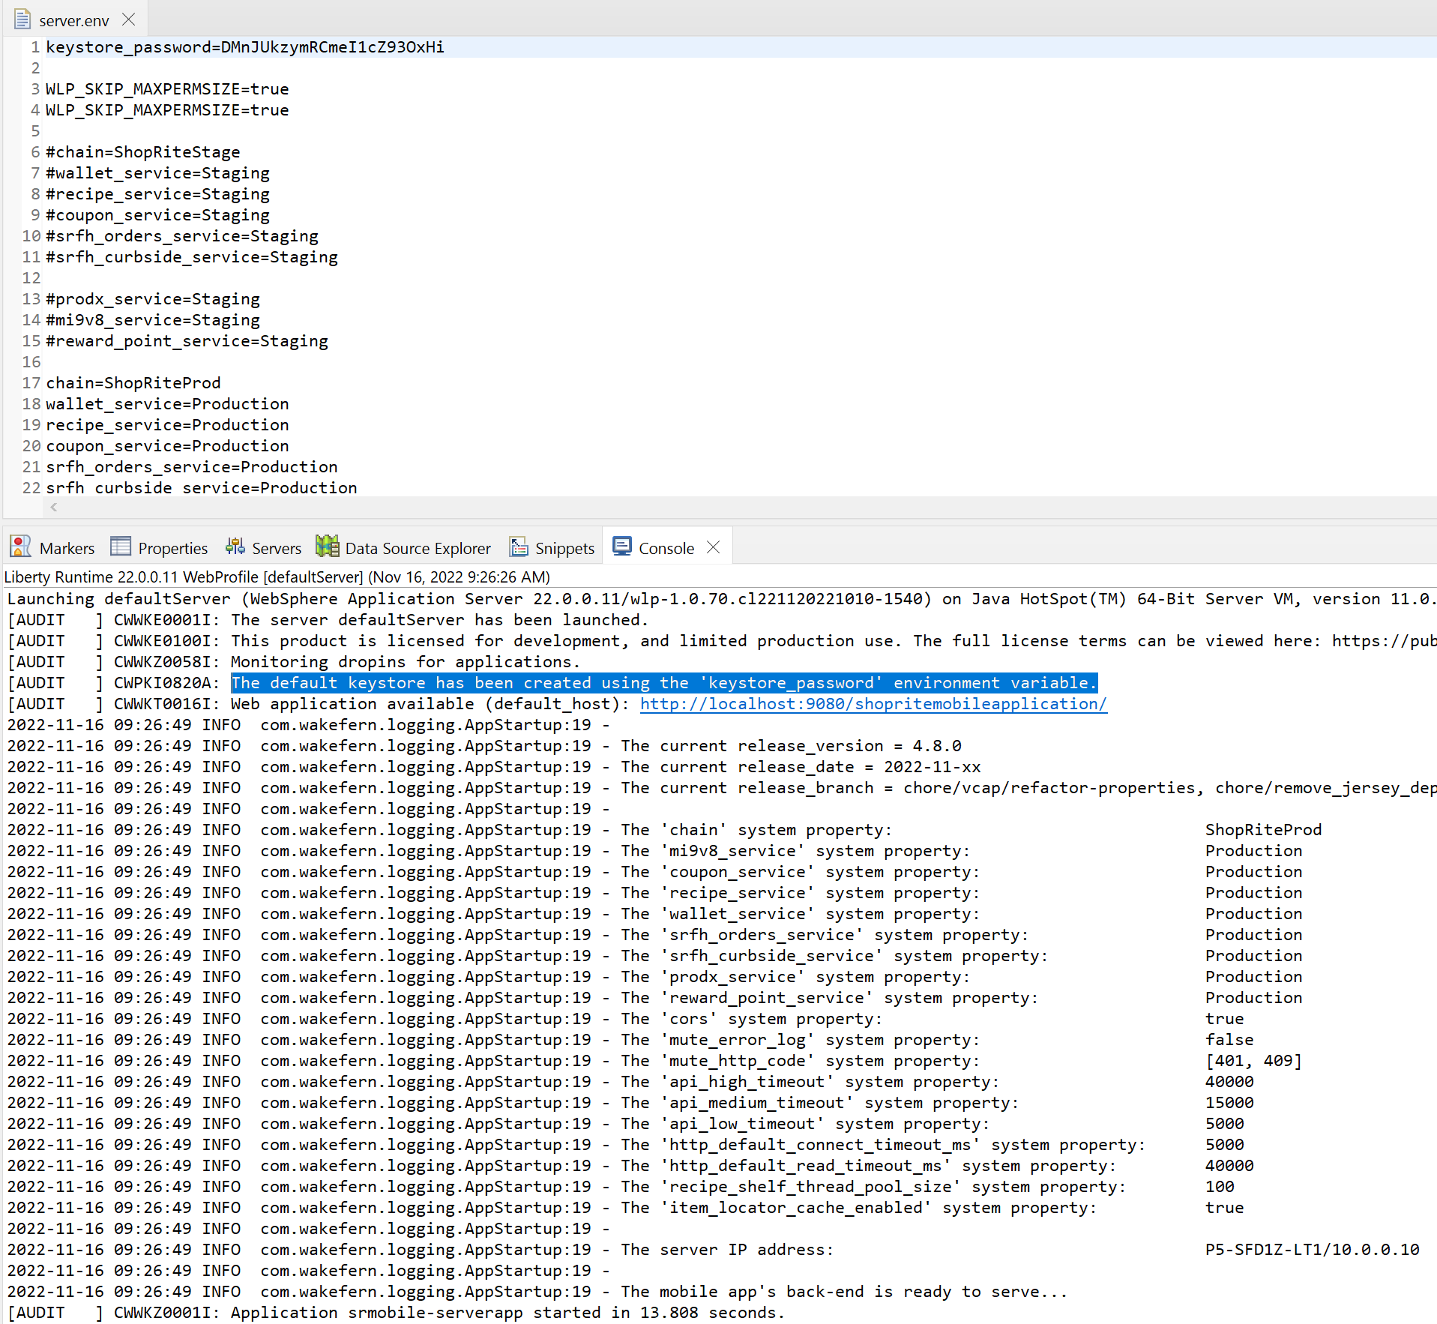

Comment out the first line since it is not needed any more after the default key-store has been created from previous screen shot.

